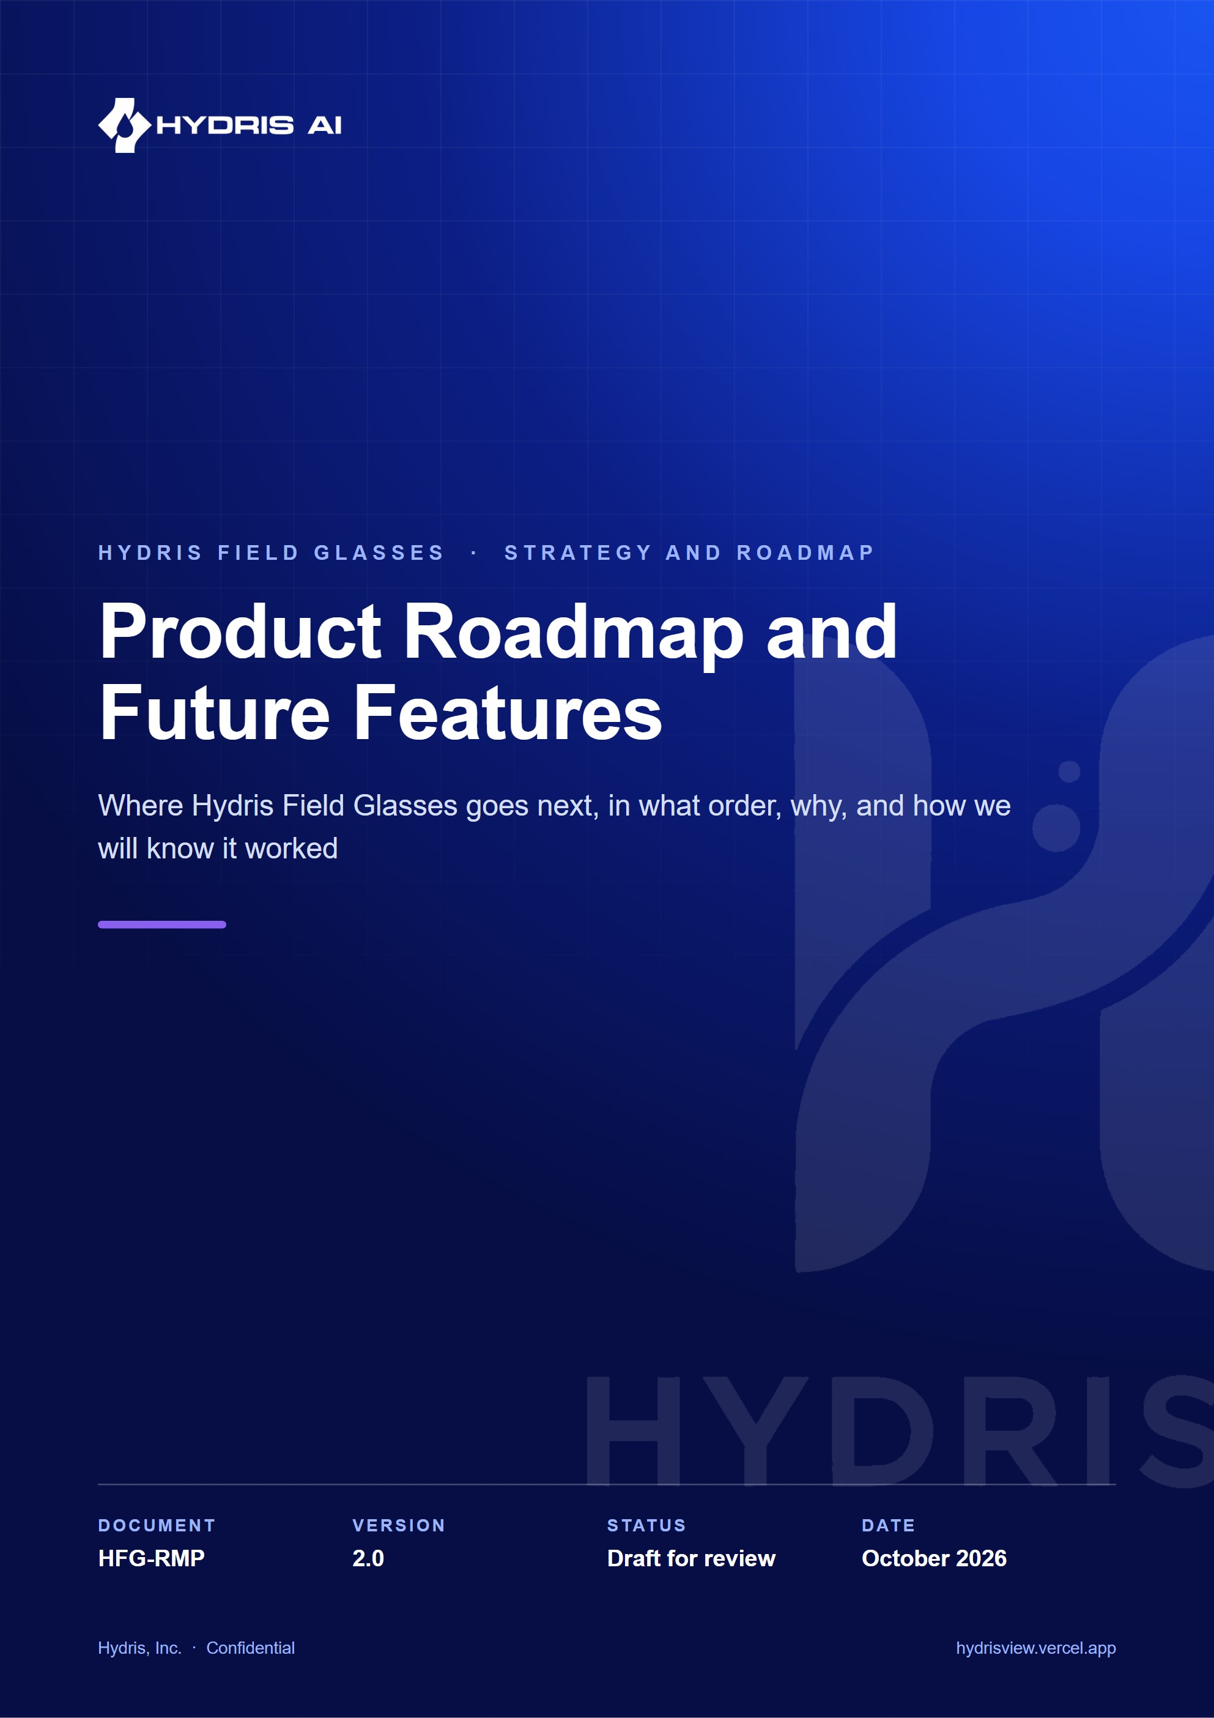
Document control
Document | Product Roadmap and Future Features (HFG-RMP)
Version | 2.0
Status | Draft for review
Owner | Product, Hydris
Audience | Leadership, product, engineering, pilot customers, partners and investors
Product | Hydris Field Glasses: website, operator console, glasses app, Android app, API
Source of truth | docs/product/ROADMAP.md in tarun-km/hydrisview (this Word file is generated from it)
Classification | Confidential: Hydris, Inc. and named partners
Revision history
Version | Date | Author | Changes
2.0 | October 2026 | Product, Hydris | Expanded edition with horizons, quarterly plan to Q4 2027, themes and epics, in-depth future features, RICE prioritisation, tech debt, risks, success metrics and release cadence

Contents
1 How to read this roadmap 5
1.1 Horizons, not dates 5
1.2 Planning assumptions 5
2 Where the product is today 6
3 Vision and horizons 8
3.1 Product vision 8
4 Timeline Q4 2026 to Q4 2027 11
5 Themes and epics 13
5.1 Theme overview 13
5.2 Hardening and tech debt 13
5.3 Mobile and glasses 13
5.4 Pilot and field success 14
5.5 Enterprise and security 14
5.6 Compliance and records 14
5.7 Integrations 14
5.8 Intelligence 14
6 Future features in depth 15
6.1 Meta display glasses and other displays 15
6.2 Offline-first sync 16
6.3 Edge gateway and industrial protocols 16
6.4 Predictive maintenance and anomaly detection 17
6.5 SOP copilot with retrieval over procedures 19
6.6 Multilingual voice 19
6.7 Computer vision for gauges and meters 20
6.8 OCEMS and CPCB and SPCB compliance automation 20
6.9 E-signatures 21
6.10 Digital twin and plant map 22
6.11 Remote expert video assist 23
6.12 iOS app 23
6.13 Mobile device management 23
6.14 Multi-site analytics 24
6.15 Marketplace and CMMS integrations 24
6.16 Certifications 24
7 Prioritisation 26
7.1 RICE scoring 26
7.2 Value versus effort 27
8 Known gaps and tech debt to close 28
9 Dependencies and risks 30
10 Success metrics per horizon 32
11 Release cadence 33
12 Open questions 34

Hydris Field Glasses already does something no other product in Indian water and wastewater does end to end: it puts live plant state, the next task, the approved procedure and a grounded voice assistant in an operator's line of sight, and it turns paper log sheets into verified, searchable records. The minimum viable product is built and runs as a zero-configuration demo. The next twelve months are about turning it into something a plant can rely on every shift, then into something a regulator, a maintenance system and a control room can rely on too.
This roadmap is a plan, not a commitment. Everything dated is an estimate that assumes the current team and no major change in Meta's developer programme. Status labels follow the house rule: Built is on main (commit 07cca23), Partial exists in code but is incomplete or unverified, Planned does not exist yet. Effort, reach and impact numbers are team estimates and are labelled as such.
5  quarters planned  Q4 2026 to Q4 2027 |  | 8  themes  From hardening to ecosystem |  | 19  future features analysed  Each with problem, outcome and dependencies |  | 1 to 2  pilot plants targeted  ETP or STP, Q1 2027 (target)

1 How to read this roadmap

1.1 Horizons, not dates
The roadmap is organised in three horizons. Now is committed work for the current and next quarter, with named owners and acceptance criteria in the QA and Test Plan. Next is planned for the following two quarters; scope may still change after pilot feedback. Later is direction: we believe these features matter and have designed their shape, but they will be re-prioritised with evidence from the pilot.
Table 1. Confidence by horizon
Horizon | Window (plan) | Confidence in scope | Confidence in dates | What changes it
Now | Q4 2026 to Q1 2027 | High | Medium | Pilot customer dates, Meta DAT access
Next | Q2 to Q3 2027 | Medium | Low | Pilot KPIs, customer requests, team size
Later | Q4 2027 and beyond | Low | Very low | Market, partners, regulation, hardware

1.2 Planning assumptions
- The team stays roughly at its current size until a pilot converts; dates assume no new hires before Q2 2027.
- Meta keeps the Wearables Device Access Toolkit (DAT) available to developers, and India-based testers can use it (unconfirmed; see Dependencies and risks).
- The first customers are Indian ETPs, STPs and CETPs with English-literate supervisors and mixed-language operators.
- Hydris remains read-only to the plant: no feature in this roadmap writes to a PLC, SCADA or DCS.

2 Where the product is today
The MVP covers every surface: website, console, glasses web app with a simulator, native Android app, and the API. The inventory below is grounded in the PRD requirement statuses and the code.
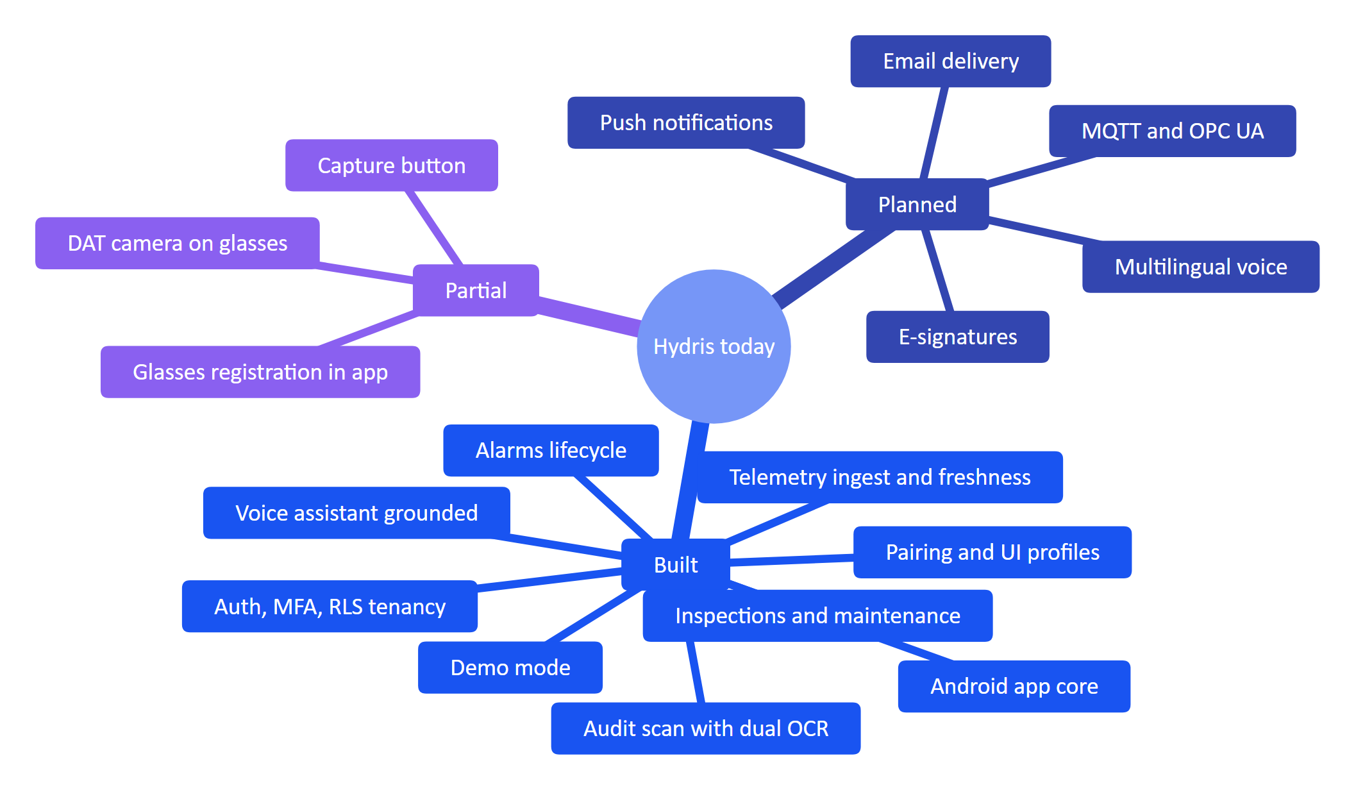
Figure 1. Capability map today (Built, Partial, Planned)
Table 2. Current state by product area
Area | What exists | Status | Evidence
Identity and tenancy | Login with lockout, TOTP MFA, refresh rotation, invitations, site scoping, Postgres RLS | Built | FR-001 to FR-010, platform.test.ts
Telemetry | 16 measurands, HTTPS gateway ingestion, manual and lab entry, append-only corrections, freshness | Built | FR-020 to FR-026
Industrial protocols | gateways.protocol enum only | Planned | FR-027, FR-028
Alarms | Rules with deadband and on-delay, lifecycle, realtime over SSE | Built | FR-030 to FR-033
Push to phones | None | Planned | FR-034
Inspections and maintenance | Templates, routes, glasses execution with offline queue, review, maintenance tasks | Built | FR-040 to FR-043
Devices | Pairing, tokens, revocation, permission ceiling, UI profiles | Built | FR-050 to FR-054
Meta glasses hardware | DAT bridge and native app integration, not run on physical glasses | Partial | FR-055 to FR-057
Audit scanning | Guided capture, dual-pass OCR, structuring, optional vision, review, four-eyes, PDF | Built | FR-060 to FR-067
E-signature | None | Planned | FR-068
Assistance and voice | SOP retrieval, "Hey Hydris", grounded answers with rules fallback | Built (English) | FR-070 to FR-072
Multilingual voice | None | Planned | FR-073
Platform | SSE replay, reports, audit trail, demo mode, simulation, in-app notifications | Built | FR-080 to FR-085
Email | Messages written to mail_outbox, never sent | Planned | FR-086
Android app | Login, demo, home, work, sensors, alarms, scan with CameraX and ML Kit, assistant, glasses screen | Built (manually verified on emulator) | apps/android
CI | None | Planned | No .github/ directory

3 Vision and horizons

3.1 Product vision
Every operator in a water or wastewater plant gets the live state of the plant, the next task and the right procedure in their line of sight, hands free, and every reading, check and paper record they touch becomes a trustworthy digital record. Over the next horizons that vision widens from the operator to the plant: the same trusted record feeds compliance reporting, maintenance systems and predictive models.
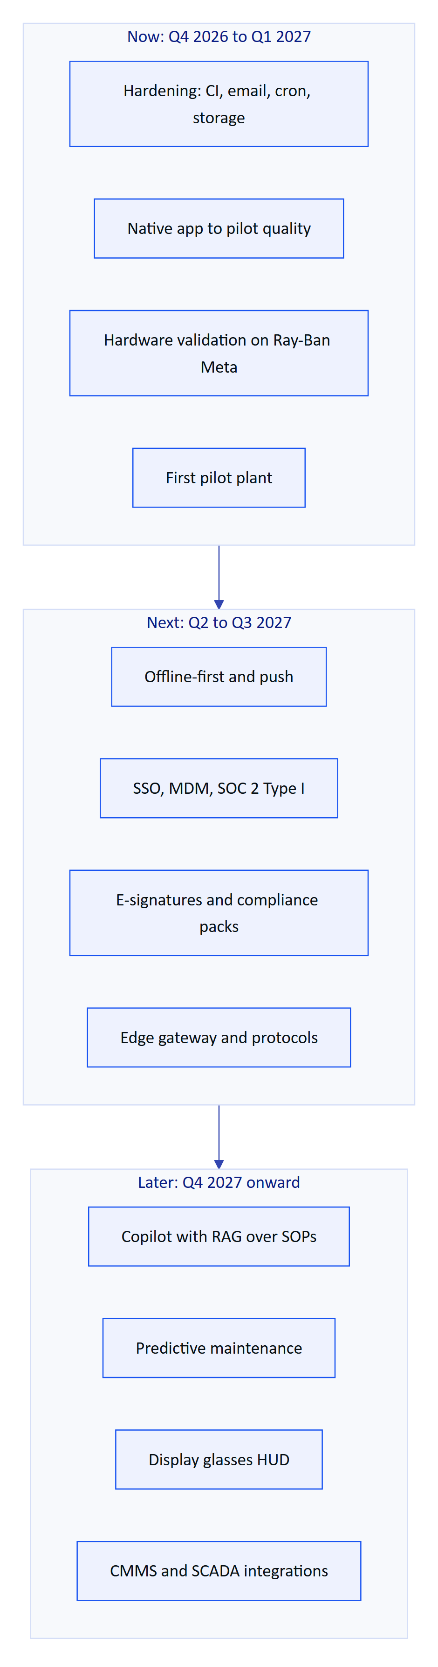
Figure 2. Three horizons: make it reliable, make it indispensable, make it the plant's system of record
Table 3. Horizon goals and exit conditions
Horizon | Goal | Exit condition
Now | A pilot plant uses Hydris every shift without engineering support on site | Pilot exit criteria in the QA plan all checked; 4 weeks of daily use
Next | A customer can buy, deploy and audit Hydris without Hydris engineers | GA release; SOC 2 Type I report; Play or MDM distribution; second paying site
Later | Hydris is the system of record for field work and compliance evidence at multi-site customers | Compliance reports generated from Hydris accepted by a regulator; one CMMS integration live

4 Timeline Q4 2026 to Q4 2027
The timeline and Gantt chart below are the plan as of October 2026. They are re-baselined at the end of every quarter.
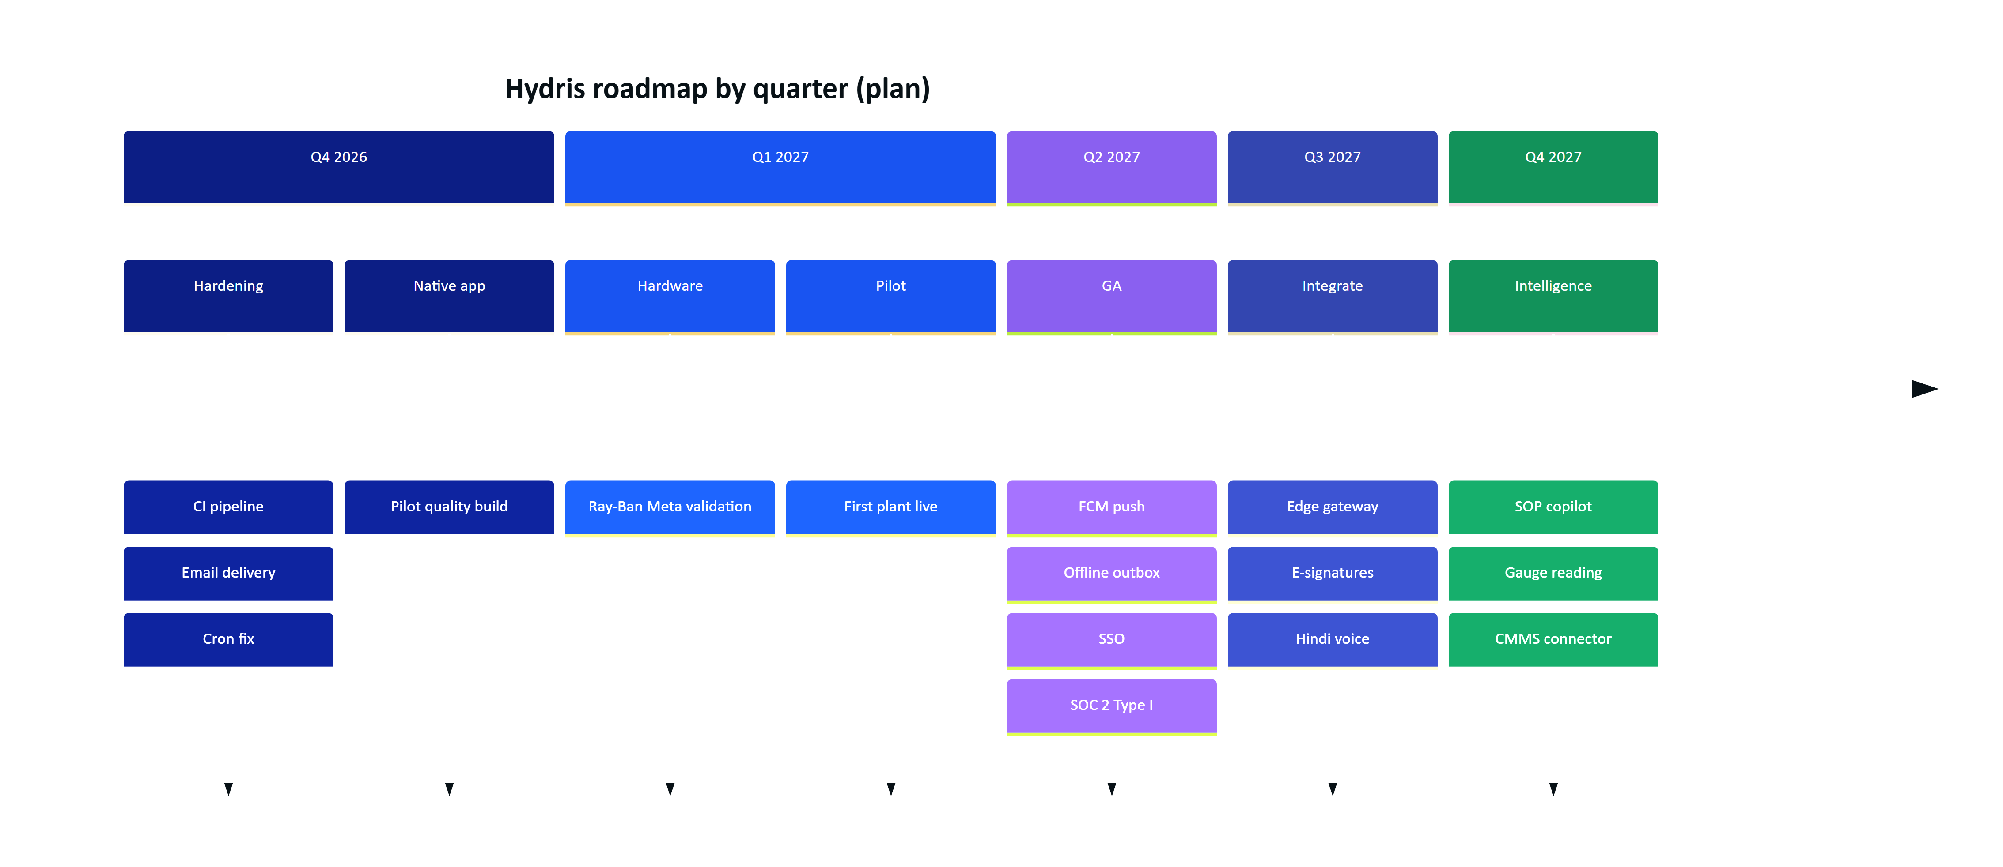
Figure 3. Quarterly milestones (plan, October 2026)
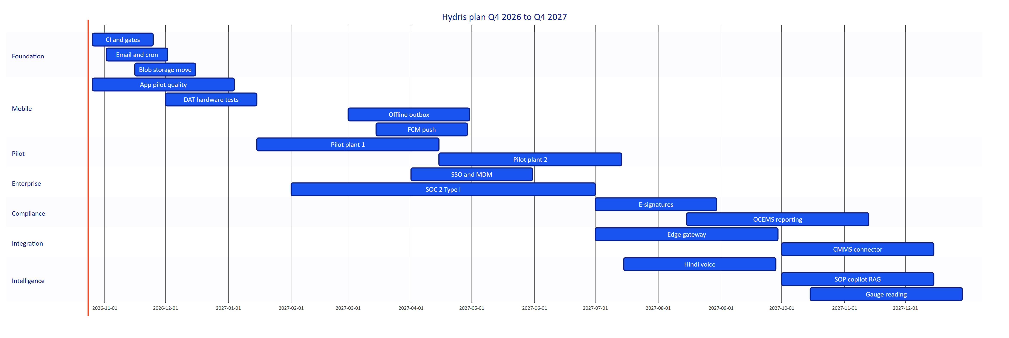
Figure 4. Quarter plan as a Gantt chart (plan; bars are estimates)
Table 4. Quarter summary (plan)
Quarter | Headline | Key deliverables | Exit signal
Q4 2026 | Make it reliable | CI, email transport, cron schedule, audit images to object storage, purge jobs, Android pilot build | Gates 1 and 2 green on every PR
Q1 2027 | Prove it in a plant | DAT hardware matrix, pilot plant 1, field trial, KPI baseline | Pilot exit criteria met
Q2 2027 | Make it buyable | GA: FCM push, offline outbox, SSO, MDM, SOC 2 Type I readiness, India-region production | Second site signed
Q3 2027 | Make it compliant and connected | E-signatures, edge gateway (MQTT, OPC UA, Modbus), Hindi voice | First e-signed record approved at a customer
Q4 2027 | Make it intelligent | SOP copilot, gauge reading, first CMMS connector, OCEMS report drafts | Copilot used weekly by 50 % of operators (target)

5 Themes and epics

5.1 Theme overview
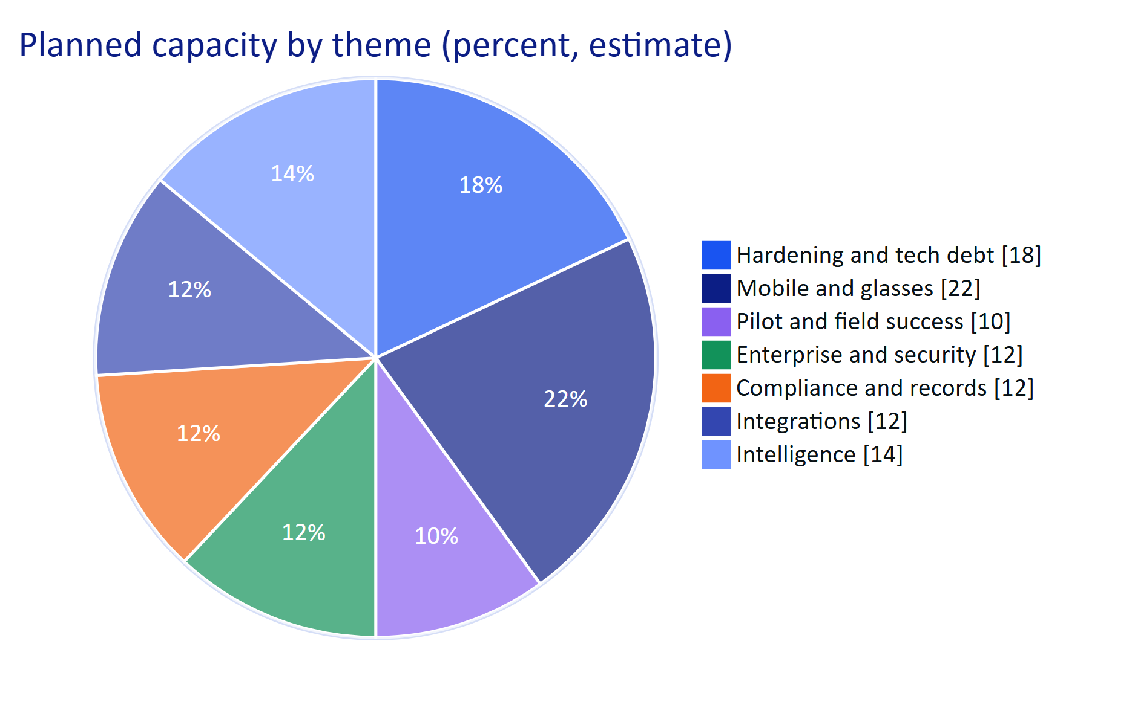
Figure 5. Share of planned engineering capacity by theme, Q4 2026 to Q4 2027 (estimate)
Each epic below states the problem, the outcome we want, the scope, the dependencies and the status. Epic IDs (EP-xx) are stable and are used in the prioritisation table.

5.2 Hardening and tech debt
EP-01 CI and quality gates. Problem: tests run only on laptops; nothing stops a regression reaching the demo. Outcome: every pull request runs typecheck, unit, API, build, Playwright and Android checks. Scope: GitHub Actions pipeline as specified in the QA and Test Plan. Dependencies: none. Status: Planned (Q4 2026).
EP-02 Email delivery. Problem: invitations and password resets are written to mail_outbox and never sent (FR-086), so a real customer cannot onboard users without manual help. Outcome: transactional email with delivery status and purge after send. Scope: SES or Resend adapter, templates, bounce handling, outbox purge. Dependencies: domain verification. Status: Planned (Q4 2026).
EP-03 Storage and retention. Problem: audit page images are base64 inside Postgres; expired sessions, pairing challenges and outbox rows are never purged (Data Model). Outcome: images in object storage with lifecycle rules; purge jobs on a schedule. Scope: migrate audit_document_pages.data to Blob or S3, purge jobs in apps/api/src/jobs.ts. Status: Planned (Q4 2026).

5.3 Mobile and glasses
EP-04 Android app to pilot quality. Problem: the native app is built and manually verified on an emulator but has no automated tests and has not run with glasses. Outcome: a signed pilot build on a Play internal track with unit and UI tests. Scope: tests, crash reporting, settings, diagnostics screen, release signing. Status: Partial.
EP-05 Ray-Ban Meta hardware validation. Problem: the DAT camera, capture button and glasses speech paths are unverified on hardware. Outcome: hardware matrix rows H1, H2 and H5 passed. Dependencies: DAT access for India-based testers, Meta AI app on test phones. Status: Planned (Q4 2026 to Q1 2027).
EP-06 Offline-first and push. Problem: operators walk through basements and pump houses with no signal; the Android app has no outbox and no push. Outcome: rounds and alarm acknowledgements work offline and sync safely; alarms reach a pocket phone in seconds. Scope: see Offline-first sync and FR-034. Status: Planned (Q2 2027).
EP-07 Display glasses. See Meta display glasses and other displays. Status: Planned (Later).

5.4 Pilot and field success
EP-08 Pilot programme. Problem: no plant has used Hydris on a real shift. Outcome: one to two Indian plants using it daily with measured KPIs. Scope: onboarding kit, site survey, camera policy pack, training, weekly KPI review, field trial. Dependencies: EP-01 to EP-05. Status: Planned (Q1 2027).

5.5 Enterprise and security
EP-09 SSO and MDM. Problem: enterprise IT will not manage another password list or side-loaded APKs. Outcome: SAML and OIDC sign-in, managed Android deployment. Status: Planned (Q2 2027).
EP-10 Certifications. Problem: due diligence questionnaires stall deals. Outcome: SOC 2 Type I, then Type II and ISO/IEC 27001. Status: Planned (Q2 2027 onward).

5.6 Compliance and records
EP-11 Electronic signatures (FR-068). See E-signatures. Status: Planned (Q3 2027).
EP-12 OCEMS and pollution control board reporting. See OCEMS and CPCB and SPCB compliance automation. Status: Planned.

5.7 Integrations
EP-13 Edge gateway and protocols (FR-027, FR-028). See Edge gateway and industrial protocols. Status: Planned (Q3 2027).
EP-14 CMMS and marketplace. See Marketplace and CMMS integrations. Status: Planned (Q4 2027).

5.8 Intelligence
EP-15 Multilingual voice (FR-073). EP-16 SOP copilot. EP-17 Gauge and meter reading. EP-18 Predictive maintenance. Each is described in depth in the next chapter. Status: Planned.

6 Future features in depth

6.1 Meta display glasses and other displays
Problem. Today's Ray-Ban Meta glasses have a camera, microphones and open-ear speakers but no display, so the Hydris HUD runs on the phone. Operators still have to look down. Display glasses (Meta Ray-Ban Display with the Neural Band, and industrial head-mounted displays) would put the live value and the next step in view.
Outcome. The same glasses web app, with its existing HUD layout and UI profiles (FR-054), renders on a display device, and input comes from the device's native gestures as well as voice.
Approach. Treat displays as rendering targets behind a small adapter: the HUD layout already exists in apps/web/src/glasses/GlassesApp.tsx, and input is abstracted in glasses/input.ts (which holds a placeholder for hardware gestures today). Candidate targets, in order: Meta Ray-Ban Display (dependent on Meta exposing display and Neural Band input to third parties), Android-based industrial headsets such as RealWear Navigator (voice-driven, hard-hat mounted), and Vuzix-class smart glasses.
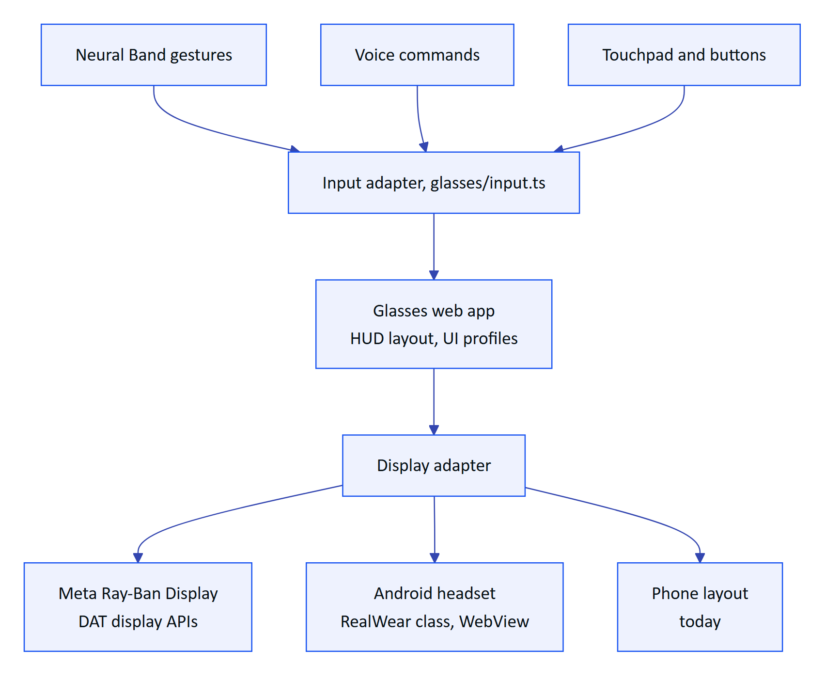
Figure 6. Display adapter design for future display glasses (planned)
Dependencies. Meta display APIs (not available to us today; Mock Device Kit does not simulate display glasses), device availability in India. Status: Planned (Later). Effort: 3 to 5 person-months per target (estimate).

6.2 Offline-first sync
Problem. Plants have dead zones. The web glasses app already queues inspection responses and replays them idempotently (client_op_id, FR-041), but the Android app has no persistent outbox, and alarm acknowledgements and readings fail without a network.
Outcome. Every field action works offline for a full shift and syncs exactly once, with clear conflict rules.
Scope. Room database cache of the operator's context (tasks, assets, latest readings, SOPs), an outbox of commands with client operation IDs, background sync with WorkManager, conflict policy (server wins for alarm state; append-only merge for readings and steps), visible "queued" counts.
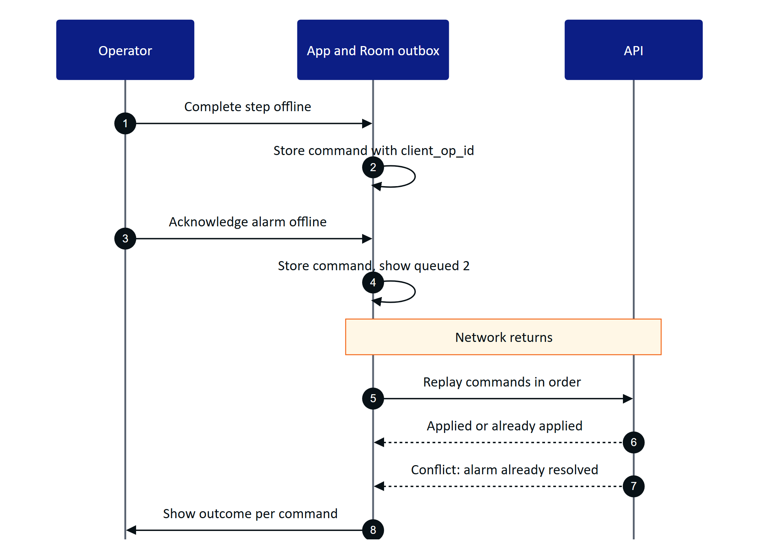
Figure 7. Offline outbox and idempotent replay (planned for Android; the web app already replays inspection steps)
Dependencies. Server endpoints accept client_op_id for alarm actions (inspections already do). Status: Planned (Q2 2027). Effort: 3 person-months (estimate).

6.3 Edge gateway and industrial protocols
Problem. Plants publish instrument data on Modbus, OPC UA and MQTT, often through a SCADA or historian. Hydris accepts HTTPS batches only (POST /ingest/v1/readings, FR-022), so each customer needs custom integration.
Outcome. A Hydris Edge gateway installed in the plant network reads tags and forwards readings outbound over HTTPS, preserving the read-only and outbound-only security model.
Scope. Containerised gateway (Docker on an industrial PC), connectors for OPC UA (subscription), MQTT (including Sparkplug B payloads), and Modbus TCP and RTU (polling), a tag mapping UI in the console, store-and-forward buffering, and read-only historian connectors (FR-028).
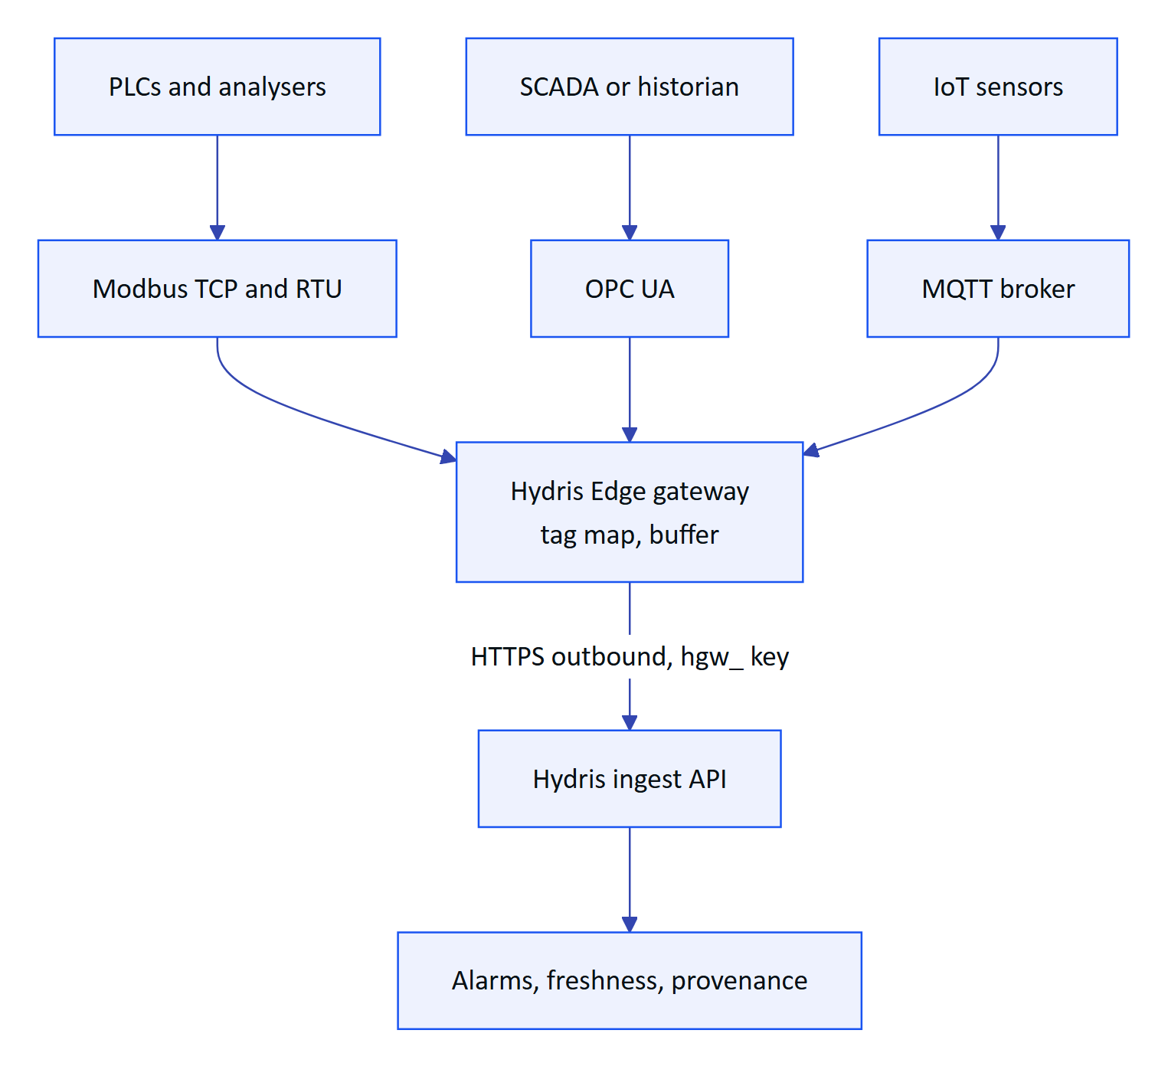
Figure 8. Edge gateway architecture (planned): outbound only, never writes to the plant
DECISION
The gateway is read-only by construction: connectors are built without write function codes or method calls, and configuration cannot enable them. This keeps Hydris outside IEC 62443 control zones, as stated in Security and Privacy.

Dependencies. Pilot customer network policy, a test rig with a PLC simulator. Status: Planned (Q3 2027). Effort: 5 person-months (estimate).

6.4 Predictive maintenance and anomaly detection
Problem. Blowers, pumps and dosing systems fail with warning signs (rising current, vibration, runtime drift) that nobody watches continuously.
Outcome. Hydris flags assets whose behaviour departs from their own normal, and creates maintenance tasks with evidence, before the failure.
Approach. Start simple and explainable: per-asset baselines and seasonal residuals, then multivariate models once there is enough labelled history. Every prediction becomes an advisory, never an automatic action, and links to the evidence charts.
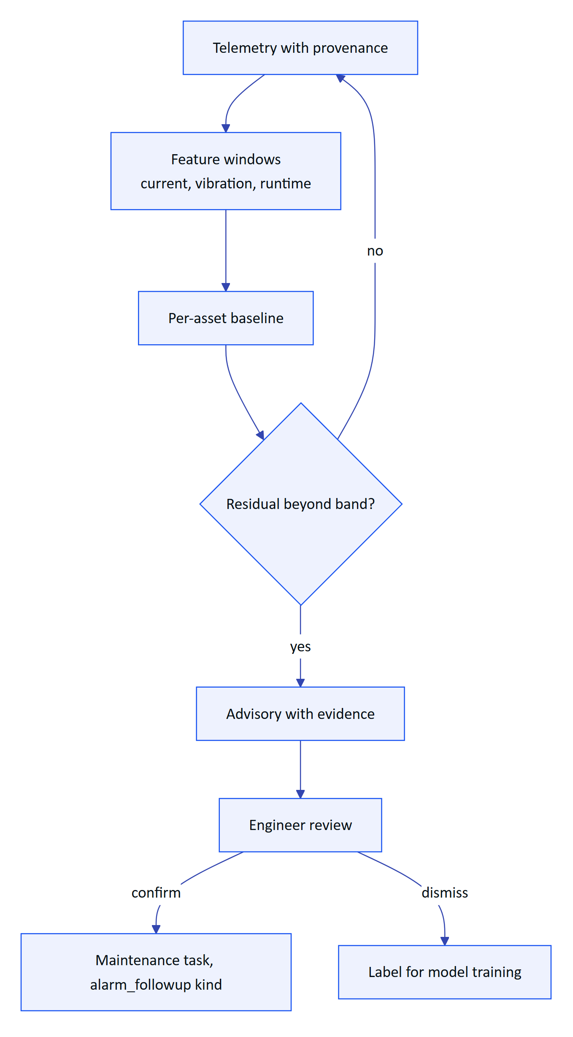
Figure 9. Anomaly detection pipeline (planned)
Dependencies. Edge gateway for high-frequency data, 6 or more months of history per asset. Status: Planned (Later). Effort: 6 person-months for the first version (estimate).

6.5 SOP copilot with retrieval over procedures
Problem. Today /assist retrieves approved SOPs and the voice assistant answers from tenant data via scoped tools (FR-070, FR-072). Operators also ask "how" and "why" questions that need the content of long procedures, manuals and past incident notes.
Outcome. A copilot that answers from the customer's approved documents with citations, in the field, and never invents a step.
Approach. Retrieval-augmented generation: chunk and embed approved documents per tenant, retrieve with RLS-scoped queries, generate with citations, and refuse when retrieval confidence is low. Safety rule kept from today: Hydris does not control equipment; for safety-critical actions it points to the approved procedure and the supervisor.
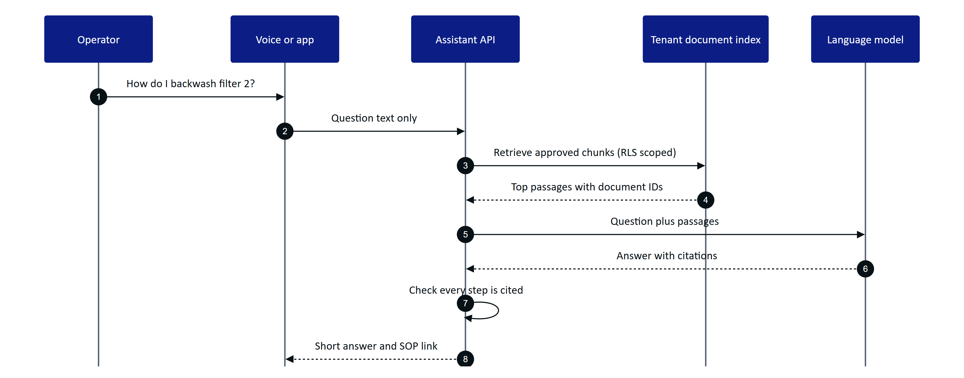
Figure 10. Copilot answer flow with retrieval and citation checks (planned)
Dependencies. Document version control (exists: document status draft, approved, archived), LLM data residency decision for Indian customers, per-org opt-out of third-party processing (planned in Security and Privacy). Status: Planned (Q4 2027). Effort: 3 person-months (estimate).

6.6 Multilingual voice
Problem. Many operators think and speak in Hindi, Tamil, Marathi, Gujarati, Telugu or Kannada, and mix languages in one sentence. The assistant is English-only (FR-073 Planned).
Outcome. Operators ask in their language and hear answers in it, with numbers and units spoken correctly.
Scope. Speech recognition with Indic language support (Android on-device recognizers and cloud options such as models trained on Indian languages), language-aware intent detection, localised wake phrase handling, TTS voices, localised UI strings, and a code-mixed test set (the QA utterance set already includes code-mixed questions).
Table 5. Language rollout order (plan)
Wave | Languages | Why first | Target
1 | Hindi | Largest operator population in early pipeline | Q3 2027
2 | Tamil, Marathi | Pilot regions (assumed) | Q4 2027
3 | Gujarati, Telugu, Kannada, Bengali | Industrial clusters | 2028

Dependencies. Recognizer accuracy in noise, numeric normalisation per language. Status: Planned. Effort: 2 person-months for Hindi, then 1 per language (estimate).

6.7 Computer vision for gauges and meters
Problem. Many plants still have analogue pressure gauges, flow totalisers and level indicators that are read by eye and written down, which is where transcription errors start.
Outcome. The operator looks at a gauge, says "read this", and Hydris proposes a value with confidence; the operator confirms it, and it is stored with the photo as provenance, like an audit scan field.
Approach. Reuse the audit scan pattern: capture on intent, machine proposes, human confirms, original kept. Dial gauge reading via needle detection and scale calibration per registered gauge; digit recognition for seven-segment and odometer-style totalisers; QR or tag on the gauge to link the asset and its calibration.
Dependencies. DAT camera validated (EP-05), labelled image set from pilot sites. Status: Planned (Q4 2027). Effort: 5 person-months (estimate). Target accuracy: within 2 % of full scale on 95 % of reads (target).

6.8 OCEMS and CPCB and SPCB compliance automation
Problem. CPCB requires online continuous effluent and emission monitoring (OCEMS) for 17 categories of highly polluting industries and for CETPs, and state boards (SPCBs) set consent conditions with periodic returns. Plants assemble these reports by hand from instruments, lab sheets and logbooks.
Outcome. Hydris assembles compliance evidence (continuous data with provenance and freshness, verified lab sheets, approved logs) and drafts the periodic reports, with every number traceable to its source.
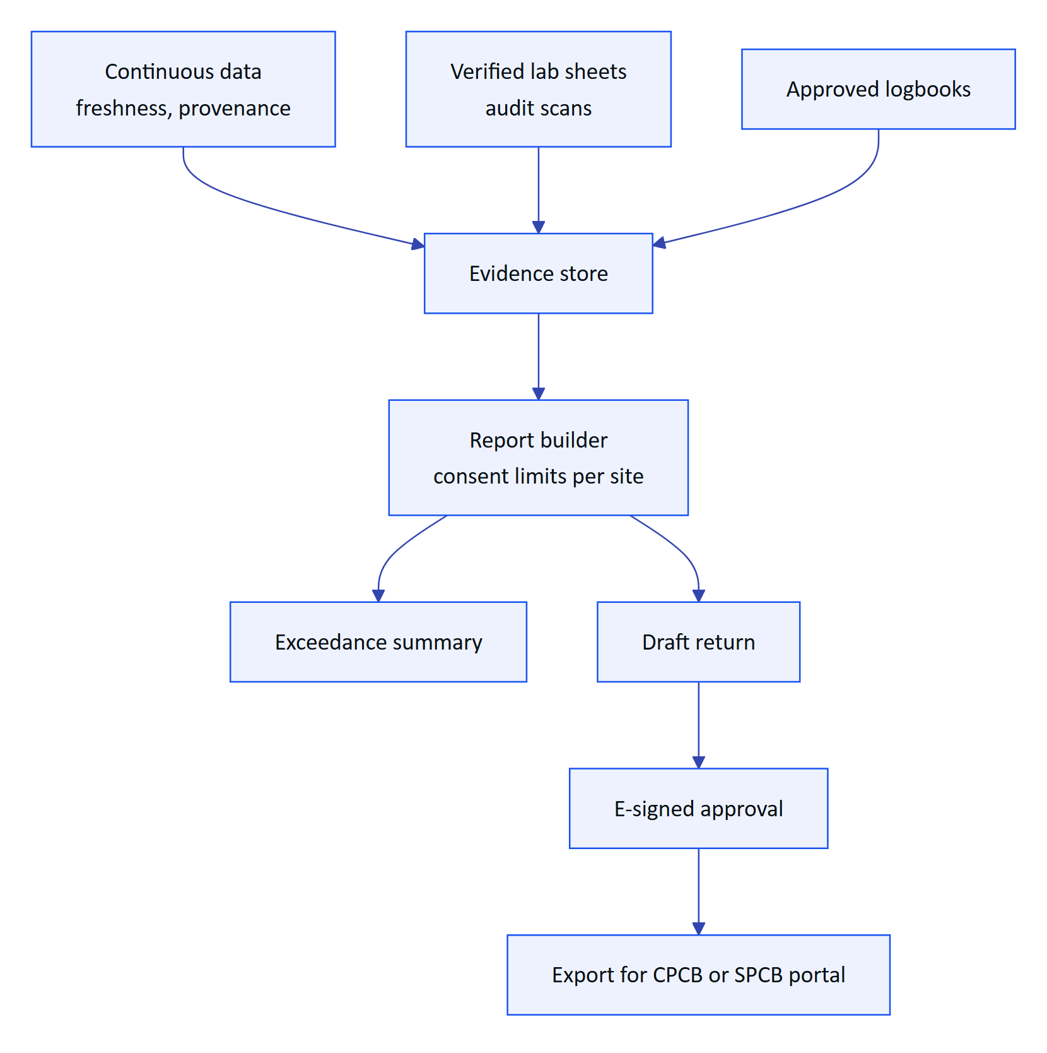
Figure 11. Compliance reporting pipeline (planned)
Scope. Consent-limit library per site, exceedance and data-availability calculations, report templates, export formats. Direct submission to CPCB or SPCB systems only where an official interface exists (to be confirmed per state).
Dependencies. E-signatures (EP-11), edge gateway for continuous data, regulator acceptance of Hydris-generated records (PRD open question). Status: Planned (Q3 to Q4 2027). Effort: 4 person-months (estimate).

6.9 E-signatures
Problem. The audit trail is append-only and approval is four-eyes (FR-065), but there is no signature manifestation: re-authentication at the moment of signing, a stated meaning ("reviewed", "approved"), and the signer's name and time bound to the record (FR-068).
Outcome. Signatures that meet Part 11-style expectations for audit documents, inspections and compliance returns, without claiming GxP validation.
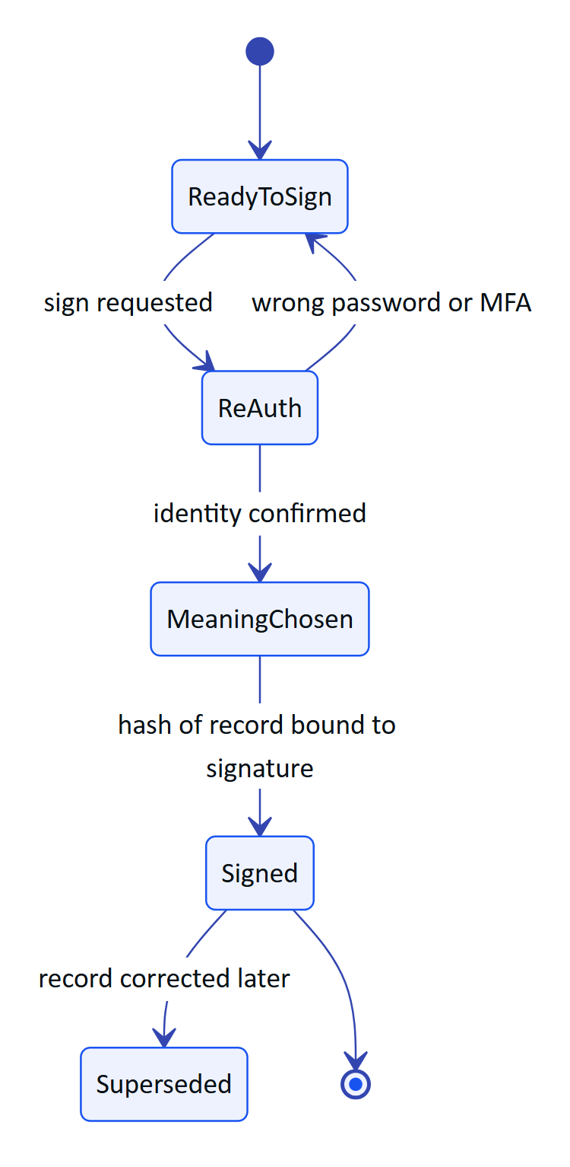
Figure 12. E-signature flow on a record (planned, FR-068)
Scope. Re-auth with password or MFA, signature meanings, record hash bound to the signature, manifestation on the PDF, signature report, lockout on repeated failures. Status: Planned (Q3 2027). Effort: 2 person-months (estimate).

6.10 Digital twin and plant map
Problem. The console has a plant map (console/map, glasses/PlantMap.tsx) with asset positions, but it is a schematic, not a living model of process flow.
Outcome. A process-flow view of the plant where each unit shows live state, open alarms, overdue tasks and data freshness, and where an operator's glasses position (by QR or BLE beacon check-in) shows nearby assets.
Scope. Process-flow layout editor, live overlays, asset check-in, "what is near me" on glasses, mass-balance views later. Status: Planned (Later). Effort: 4 person-months (estimate).

6.11 Remote expert video assist
Problem. When a junior operator faces an unfamiliar fault, the expert is often at another site or vendor office.
Outcome. The operator starts a call from the glasses; the expert sees the glasses camera view, talks to the operator and annotates frames; the session summary is saved against the asset.
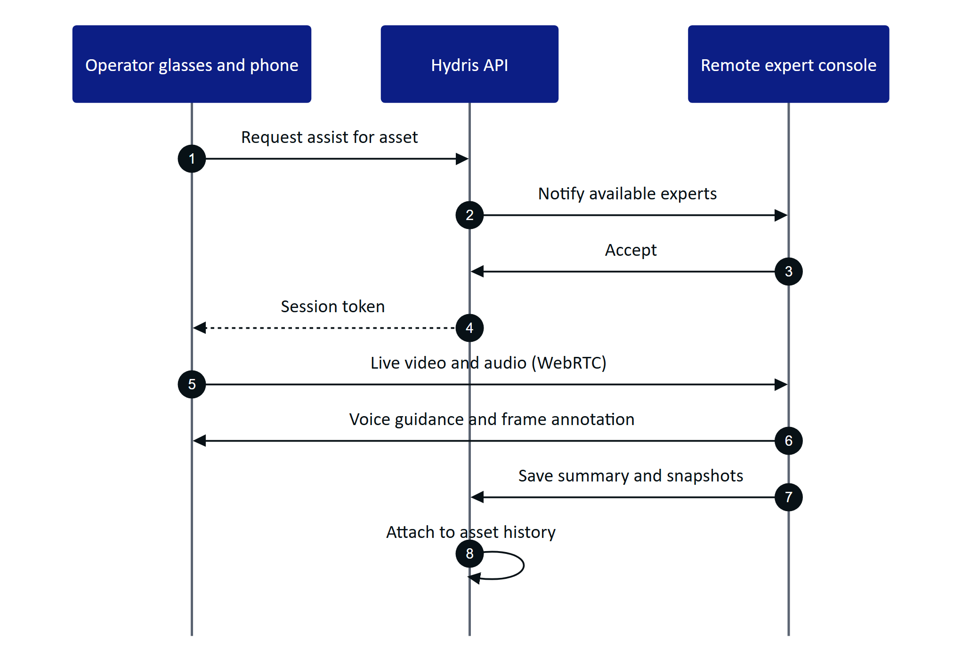
Figure 13. Remote assist session (planned)
Dependencies. DAT video streaming bandwidth over the phone link, plant network uplink, consent for recording. Status: Planned (Later). Effort: 3 person-months (estimate).

6.12 iOS app
Problem. Some customers' supervisors and managers carry iPhones. Operators in Indian plants mostly use Android.
Outcome. An iOS companion for supervisors first (alarms, reviews, approvals), then operators if Meta's iOS DAT support and customer demand justify it.
Status: Planned (Later; PRD open question 5). Effort: 6 person-months (estimate).

6.13 Mobile device management
Problem. Pilot phones are set up by hand. Enterprises require managed devices, app configuration and remote wipe.
Outcome. Hydris Field supports Android Enterprise managed configuration (server URL, SSO, kiosk options), works in work profiles, and is distributable through managed Google Play.
Status: Planned (Q2 2027). Effort: 1.5 person-months (estimate).

6.14 Multi-site analytics
Problem. Reports today are per organization and per site (FR-081). Groups that run many STPs (municipal bodies, CETP operators, facility managers) need comparisons.
Outcome. Cross-site dashboards: compliance status, alarm response times, round completion, data availability, and benchmarks across sites.
Status: Planned (Later). Effort: 3 person-months (estimate).

6.15 Marketplace and CMMS integrations
Problem. Large customers run maintenance in SAP Plant Maintenance or IBM Maximo. Hydris maintenance tasks (FR-043) would otherwise duplicate work orders.
Outcome. Two-way sync of work orders and asset master data with the customer's CMMS, plus outbound webhooks for other systems (LIMS, ERP, ticketing).
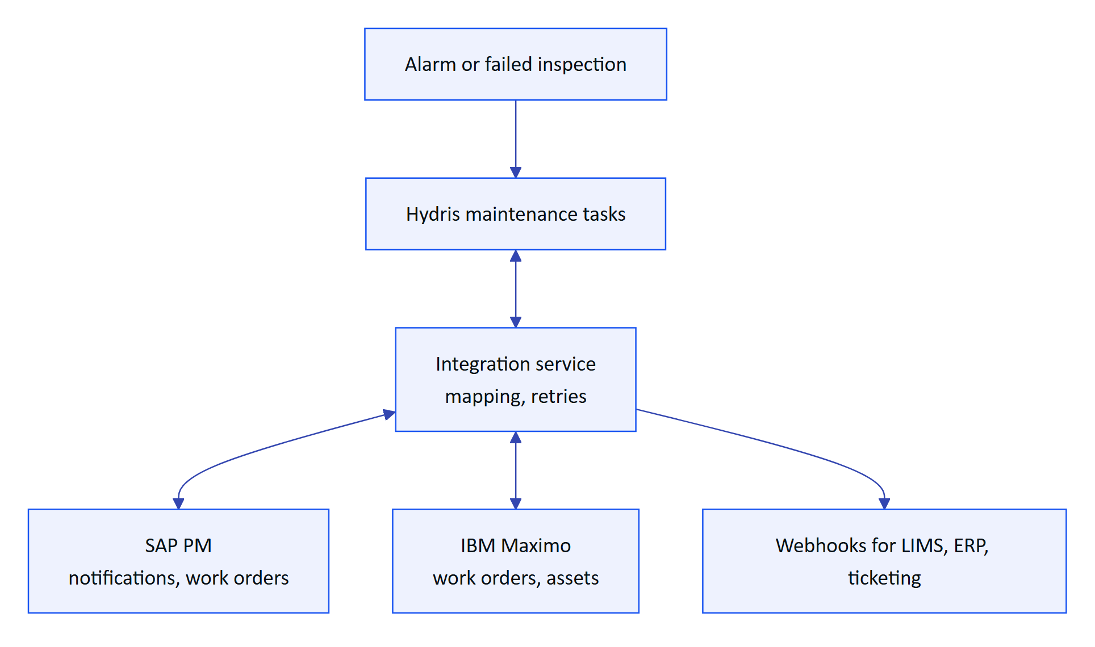
Figure 14. CMMS integration pattern (planned)
Status: Planned (Q4 2027 onward). Effort: 4 person-months for the first connector (estimate).

6.16 Certifications
Table 6. Certification plan (targets)
Certification | Why | Target
SOC 2 Type I | Customer due diligence for SaaS | Q2 2027 readiness
SOC 2 Type II | Operating effectiveness over time | 2028
ISO/IEC 27001:2022 | Common Indian enterprise and PSU requirement | 2028
IEC 62443-4-1 practices for the edge gateway | Industrial customers' OT security reviews | Assessment with the gateway
Intrinsically safe hardware | Not a Hydris certification; depends on glasses and phone vendors for hazardous zones | Customer-specific

7 Prioritisation

7.1 RICE scoring
RICE = Reach x Impact x Confidence / Effort. Reach is operators or users affected per quarter after launch; impact is on a 0.25 to 3 scale; effort is person-months. All values are team estimates (October 2026). Hardening epics (EP-01 to EP-03) are prerequisites and are not scored.
Table 7. RICE scores for candidate epics (estimates)
Epic | Reach | Impact | Confidence | Effort | RICE
FCM push | 300 | 1 | 90 % | 1 | 270
SSO | 300 | 1 | 90 % | 1.5 | 180
Offline-first sync | 300 | 2 | 80 % | 3 | 160
MDM | 300 | 0.5 | 80 % | 1.5 | 80
E-signatures | 100 | 2 | 80 % | 2 | 80
SOP copilot | 300 | 1 | 70 % | 3 | 70
Multilingual voice | 250 | 2 | 50 % | 4 | 63
Edge gateway | 200 | 2 | 60 % | 5 | 48
OCEMS reporting | 80 | 3 | 50 % | 4 | 30
CMMS connector | 100 | 2 | 50 % | 4 | 25
Remote assist | 100 | 1 | 60 % | 3 | 20
Digital twin map | 150 | 1 | 50 % | 4 | 19
Multi-site analytics | 40 | 2 | 70 % | 3 | 19
Gauge reading | 200 | 1 | 40 % | 5 | 16
Display glasses HUD | 50 | 2 | 40 % | 4 | 10
iOS app | 60 | 1 | 70 % | 6 | 7
Predictive maintenance | 50 | 2 | 30 % | 6 | 5

NOTE
RICE ranks within a horizon; it does not override dependencies or strategy. OCEMS reporting scores low on reach but is scheduled in Q3 to Q4 2027 because it is a buying reason for the highest-value segment (17 categories and CETPs).

7.2 Value versus effort
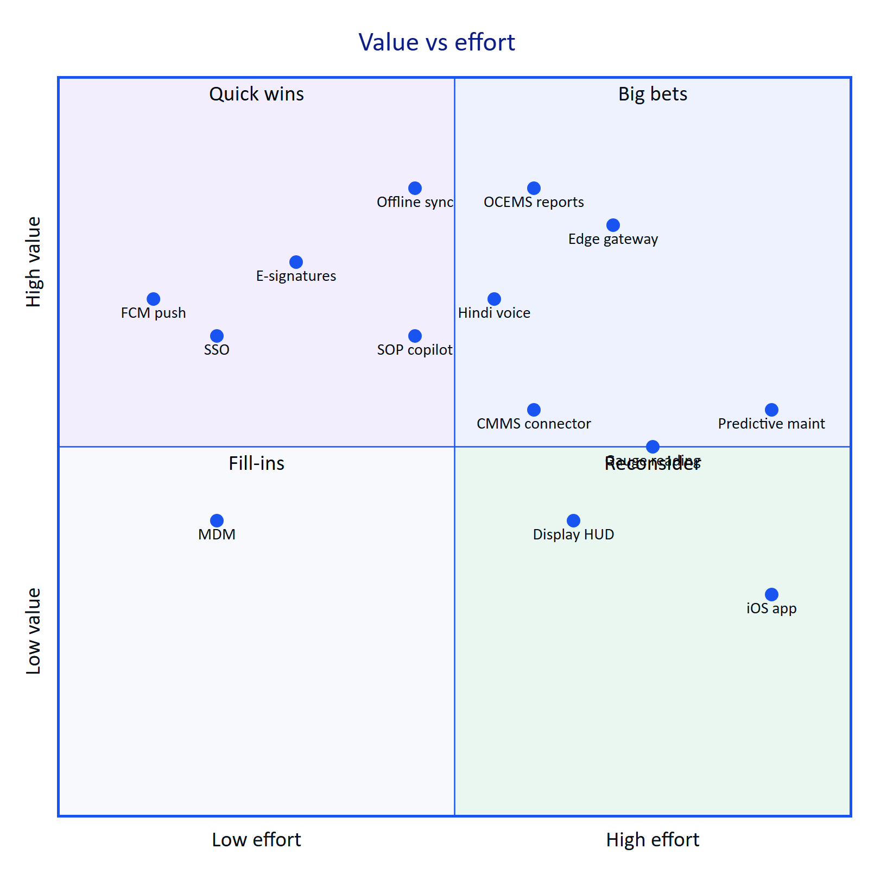
Figure 15. Value versus effort for candidate epics (team estimates)

8 Known gaps and tech debt to close
These items come from the product documents and the code. Most block an external pilot.
Table 8. Gaps and tech debt
Item | Where | Impact | Fix | Target
No CI pipeline | No .github/ | Regressions reach the demo | EP-01 | Q4 2026
Email not wired | mail_outbox, FR-086 | Invites and resets never arrive | EP-02 | Q4 2026
Cron runs daily on Vercel | vercel.json 0 3 * * * | Stale-data alarms evaluated once a day | Per-minute schedule (Pro plan) or external scheduler | Q4 2026
Device refresh token in localStorage | Web glasses runtime glasses/link.ts | Token theft on a compromised device | Native app (Keystore, built); shorter TTL or bound tokens for web | Q1 2027
Audit images as base64 in Postgres | audit_document_pages.data | Database bloat, slow backups | Object storage with lifecycle | Q4 2026
No purge jobs | auth_sessions, device_sessions, pairing_challenges, mail_outbox | Personal data kept indefinitely | Purge 30 days after expiry; outbox after send | Q4 2026
No e-signature | FR-068 | Regulated customers hesitate | EP-11 | Q3 2027
Pairing TTL documentation mismatch | docs/operations/vercel.md says about 10 minutes; code PAIRING_TTL_S = 300 | Support confusion | Correct the doc to 5 minutes | Q4 2026
Mobile spec status outdated | MOBILE_APP_SPEC.md says apps/android not on main | Misleads readers | Update spec | Q4 2026
No Android automated tests | apps/android | Manual regression only | EP-04 | Q4 2026
DAT paths unverified on hardware | FR-055 to FR-057 | Glasses features may fail on device | EP-05 | Q1 2027
No per-org opt-out of third-party AI processing | Security and Privacy | Blocks some customers | Org setting | Q2 2027
No device attestation | Native app | Spoofed clients | Play Integrity | Q2 2027
Audit log not hash-chained | audit_events | Weaker tamper evidence | Hash chain or WORM export | Q3 2027

- ☐ CI pipeline with gates 1 and 2
- ☐ Email transport and outbox purge
- ☐ Cron schedule fixed
- ☐ Audit images moved to object storage
- ☐ Purge jobs for expired sessions and challenges
- ☐ Pairing TTL documentation corrected
- ☐ Mobile spec status updated
- ☑ Native app stores tokens in Android Keystore (SecureStore.kt)

9 Dependencies and risks
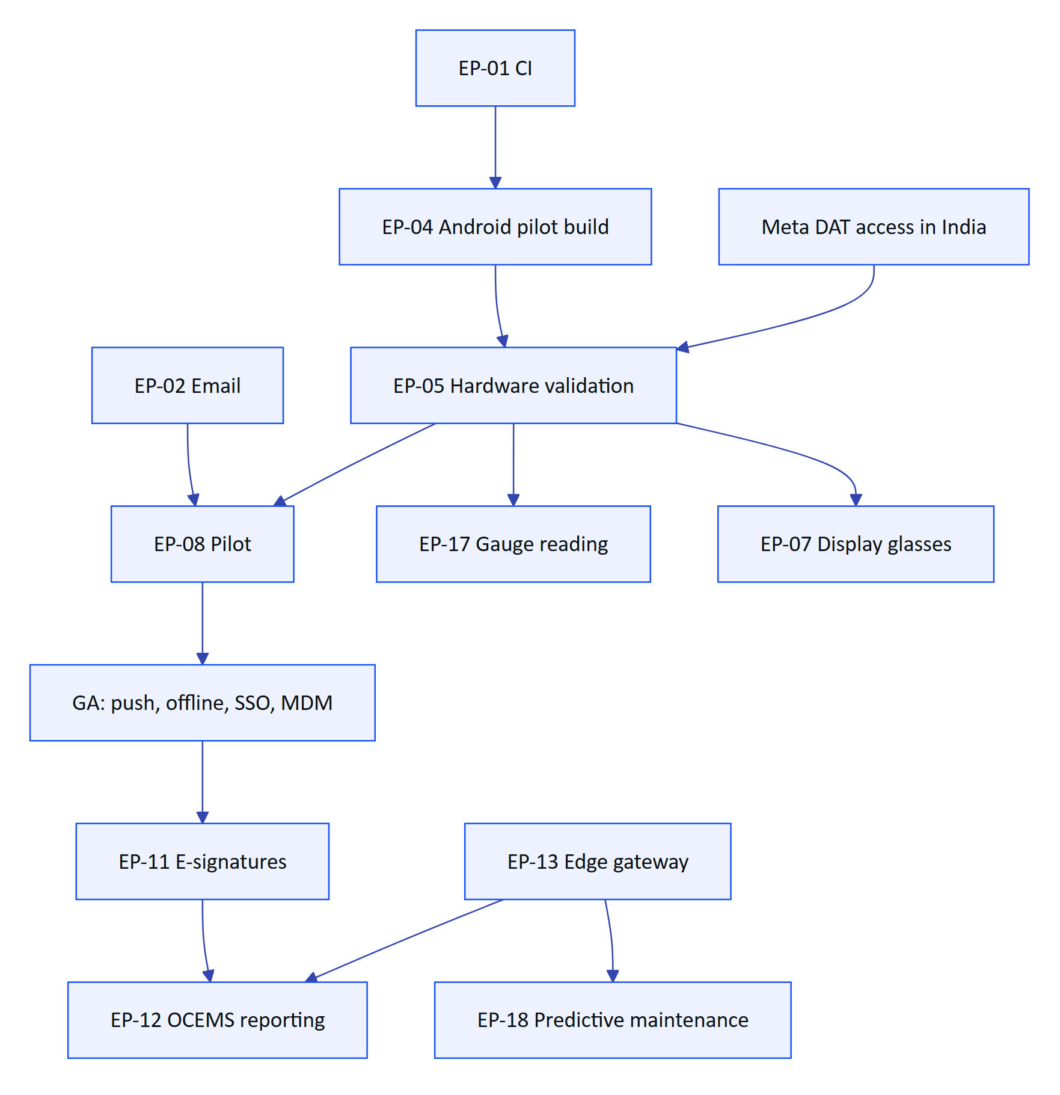
Figure 16. Key dependencies between epics (plan)
Table 9. Roadmap risks
Risk | Likelihood | Impact | Mitigation
Meta DAT not available to India-based developers or publishing stays gated | Medium | High | Pilot via release channels and Developer Mode; phone-camera path works without DAT
Meta AI app dependency causes support load | High | Medium | Onboarding checklist, version check screen
Pilot customer delays (approvals, camera policy) | High | High | Site camera policy pack early; second pilot candidate in parallel
Regulators do not accept Hydris records as primary | Medium | High | E-signatures, PDF with trail, engage SPCBs early
LLM data residency required | Medium | Medium | Rules engine fallback exists; region-pinned provider
Small team spread across too many surfaces | High | High | Strict horizon discipline; Later items stay unstarted until GA
Display glasses APIs never open to third parties | Medium | Low | Industrial Android headsets as alternative target

10 Success metrics per horizon
Table 10. Success metrics (targets)
Horizon | Metric | Target
Now | Pilot exit criteria complete | 100 %
Now | Round completion on time at pilot | 95 % (PRD)
Now | Median alarm acknowledgement time | Under 5 min (PRD)
Now | Audit fields machine-agreed | 90 % (PRD)
Next | Weekly active operators / licensed | 70 % (PRD)
Next | Paying sites | 3
Next | Offline actions synced without duplicates | 100 %
Next | SOC 2 Type I | Report issued
Later | Compliance reports generated in Hydris | 1 regulator accepted
Later | Copilot answers with citations | 90 % of answered questions
Later | Multi-site customers | 2

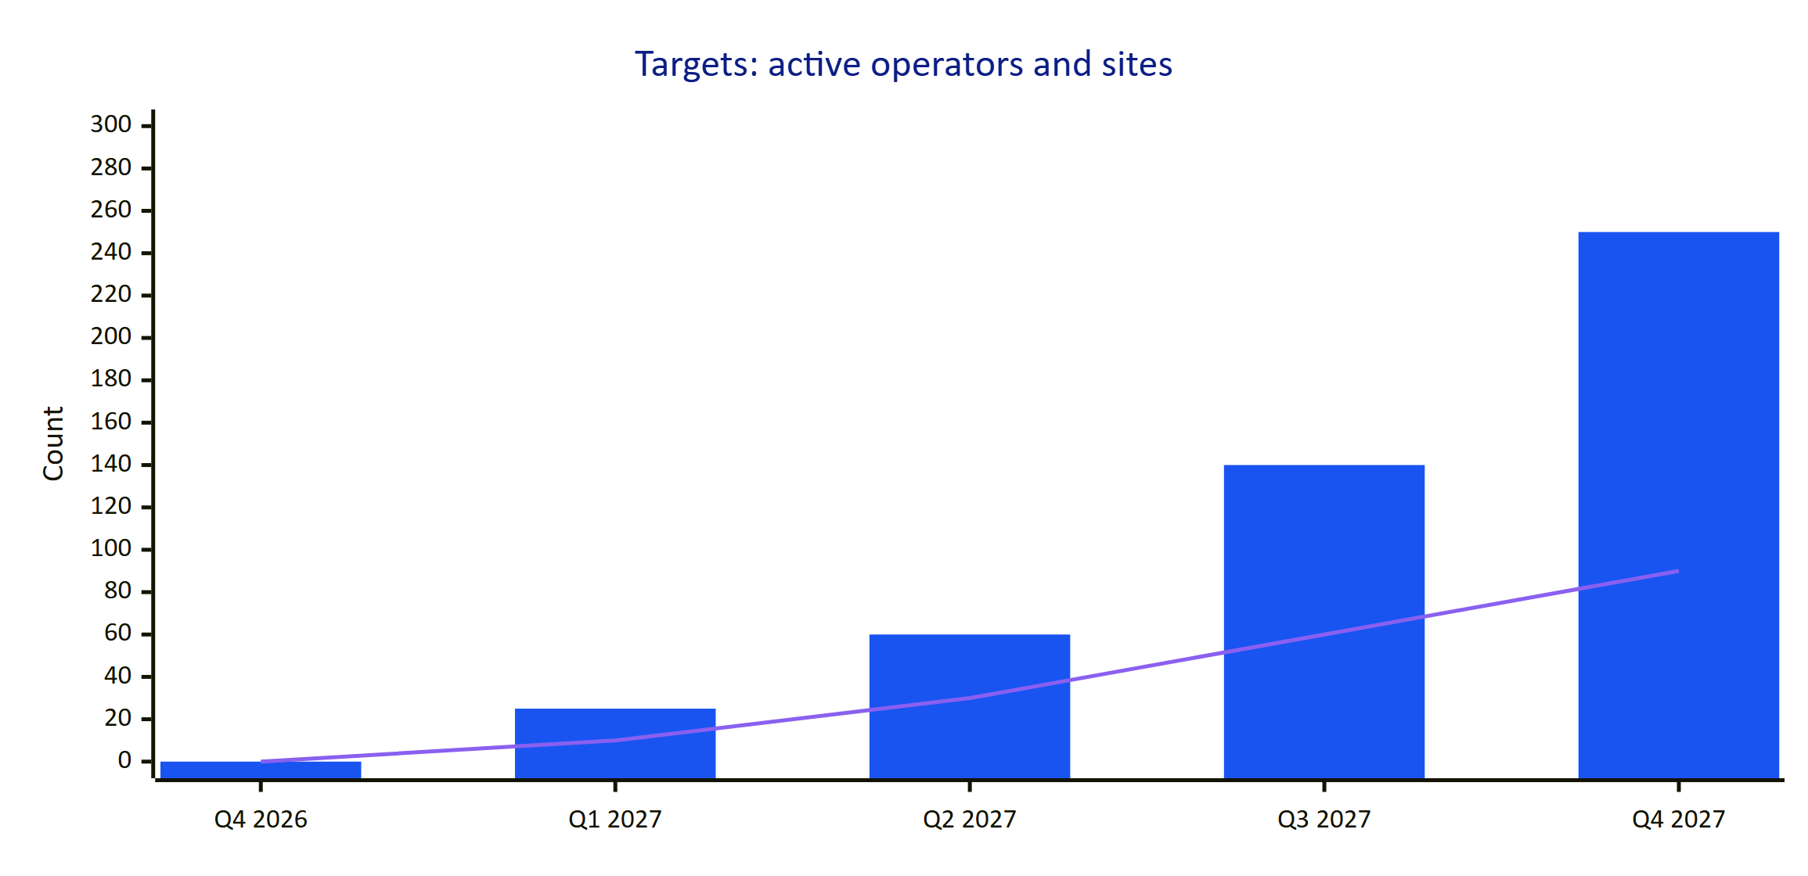
Figure 17. Adoption targets by quarter (planning targets, not measurements)
In the chart, bars are weekly active operators and the line is sites x 10 (so 90 means 9 sites). Both are targets.

11 Release cadence
Table 11. Release cadence (plan)
Surface | Cadence | Channel | Notes
API and web (console, glasses web app, website) | Continuous to staging; weekly to production after gates | Vercel | Hotfix within 24 h for S1
Android app | Every 2 weeks | Play internal, then closed track, then managed Play | Glasses features behind remote flags
Edge gateway | Monthly | Signed container images | Customer-controlled upgrade window
Documentation | With each release | docs/product and Word editions | Version and change line updated

Every release carries release notes listing requirement IDs changed, known issues and migration notes. Major features ship behind organization-level flags so pilots can opt in.

12 Open questions
- Is India among Meta's supported countries for full DAT capabilities, and when do store submissions open?
- Which pilot plants (ETP, STP or CETP) and which state boards will shape the first compliance pack?
- Will customers accept glasses cameras in plant areas, and which zones must be camera-free?
- Is a region-pinned LLM provider required before the copilot ships?
- Which CMMS do the first enterprise prospects use: SAP PM, Maximo or something else?

